PAC-Poly-Rapa Nui-*Moai kavakava* or "ribbed statue"

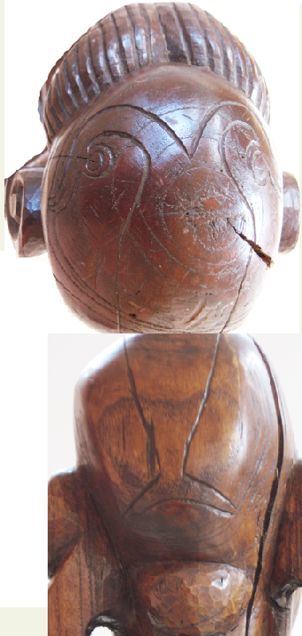

The double-headed sooty tern image on the top of Atlantika’s

*Moai Kavakava* head.

The *Moai kavakava* or "ribbed statue" in the Rapanui language depicts an aged man who had, in his youth, succeeded in being one of the first to acquire the egg of the sooty tern from the islet of Moto Nui and to swim back with it to the southwest coast of Rapa Nui. There, on the southwest promontory of Orongo on Rapa Nui, he was made Bird-Man or *Hopu* of the year. The bald head of this *Hopu* has the tattoo of a double-headed sooty tern as this badge of office for a year, since, in Polynesia, the top of the head was considered the seat of spiritual power. The double-headed sooty tern indicates the spiritual history of the Rapa Nui Polynesians, which looks back to the past transgressions of the people and forward to the future atonement made by the yearly *Hopu*. This statue is carved from indigenous hardwood of the *toromiro* tree. The eyes are wide-open as symbols indicative of a visionary, similar in intent to the peering eyes of the basalt *Moai*. The whites of the eyes are of the vertebrae of the great white shark, and the pupils are of obsidian from one of the three volcanoes on the island. This statue stands slightly off-balance and displays emaciated ribs and a protruding spine to accentuate selfless starvation as a further atonement for the people. Elongated ears denote his elevated status as an *ali'I* or revered wise, champion bird-man or *Hopu*, who had once risked his life in a symbolic effort to atone for his people’s transgressions. No longer able to repeat the feat of securing the symbolic sooty tern egg, this *Hopu* now stands as a mute sentinel as the once and future champion of his people.